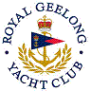 | Royal Geelong Yacht Club Inc.  Est 1859
Trophy Deed of Gift.

Trophy: | Moocher Trophy
Presented by: | Peter Jackson
Date: | 1970
For: | Fireball Handicap Aggregate Winner
Remarks / Revisions | Click here for a List if Recipients

